Biotinylated Human VEGF110 Protein; His-Avi Tag

Product Information
Product Name | Biotinylated Human VEGF110 Protein; His-Avi Tag
Storage temp | Store at ≤ -70℃, stable for 6 months after receipt.  Recommend to aliquot the protein into smaller quantities for  optimal storage. Please minimize freeze-thaw cycles.
Catalog# / Size | GM-88073RP-25 / 25 μg
Catalog# / Size | GM-88073RP-200 / 200 μg

Protein Information
Alternative Names | RP1-261G23.1, MGC70609, MVCD1, VEGFA, VPF
Source | Biotinylated Human VEGF110 Protein; His-Avi Tag (GM-88073RP) is expressed from human 293 cells (HEK-293). It contains AA Ala 27 - Arg 136 (Accession # P15692-1).  This protein carries a His-Avi tag at the N-terminus.
Purity | > 95% as determined by SDS-PAGE
Endotoxin | < 1 EU/μg, determined by LAL gel clotting assay
Predicted Mol Mass | 15.3 KDa
Formulation | Supplied as a 0.2 μm filtered solution of PBS, pH7.2-7.4.
Description | VEGFA (Vascular Endothelial Growth Factor A) is a key pro-angiogenic factor. It mainly activates downstream signaling pathways by binding to VEGF receptors (such as VEGFR1/VEGFR2), promoting proliferation, migration, and neovascularization of endothelial cells. It plays important roles in embryonic development, tissue repair, and physiological maintenance of vasculature, while also having significant impacts in pathological contexts such as tumor growth, inflammation, and chronic diseases.  VEGFA gene(s) have multiple splicing variants, with the most common being VEGF-A165 and VEGF-A121. These are produced by different exon combinations and exhibit distinct diffusion properties and biological activities. VEGFA acts in concert with its receptor signaling axis (primarily VEGFR2/KDR), triggering pathways such as PI3K/AKT and MAPK/ERK to regulate the formation, stability, and permeability of vascular networks. These variants and regulatory mechanisms together determine the intensity and spatial-temporal distribution of angiogenesis.

SDS-PAGE
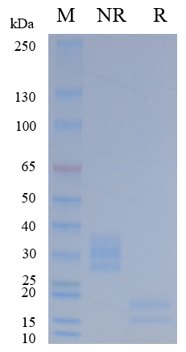
On SDS-PAGE under nun-reducing (NR) condition and reducing (R) condition. The gel was stained overnight with Coomassie Blue. The purity of the protein is greater than 95%.

Bioactivity-ELISA
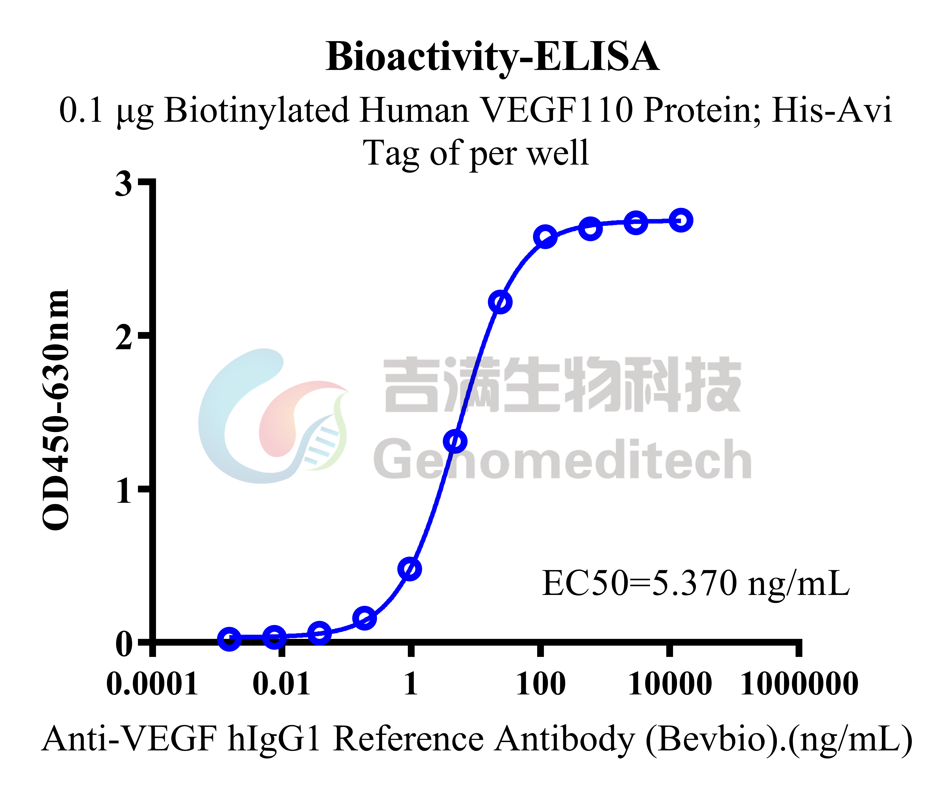
Biotinylated Human VEGF110 Protein; His-Avi Tag (Catalog # GM-88073RP) was immobilized at 1 μg/ml (100 μL/well) on streptavidin precoated. Increasing concentrations of Anti-VEGF hIgG1 Reference Antibody (Bevbio) (Catalog # GM-87758MAB) were added.

